**International Journal of Business & Management Science**

[ISSN (Online):](http://oapub.org/edu/index.php/ejes) 2456 -6063

[Volume 11 Issue 01 June 20](http://oapub.org/edu/index.php/ejes)25

**DOI:** **10.53555/eijbms.v11i1.231**

HOW DO TECHNOLOGY-DRIVEN PLATFORMS AND DIGITAL MARKETING STRATEGIES INFLUENCE CONSUMER BEHAVIOR AND BUSINESS GROWTH IN THE HOME DÉCOR INDUSTRY?

**Nittya Baid\***

*\*The British School New Delhi.*

***\*Corresponding Author:***

*\*Email: nittyabaid@gmail.com*

***1.Abstract***

*Home Decor Industry is being revolutionized by the speed of technology-backed platforms and digital marketing campaigns. This paper encapsulates the effect of such technologies on business expansion and customer activity in the industry. Since the advent of e-commerce, social media, and even newer technologies such as augmented reality (AR), artificial intelligence (AI), the process of how customers come across, find out about, and buy home decor has been completely overhauled. Instagram, Pinterest, TikTok are some of the major platforms for inspiration and engagement, and AR apps such as IKEA Place and Wayfair's Virtual Room Planner enhance the purchasing process by enabling customers to see products in their own space.*

*It is digital marketing practices such as influencer partnerships, customized advice, and market insights that are becoming the customer opinions and sales drivers. AI technology is helping companies provide personalized shopping experiences, which are raising customer satisfaction levels and loyalty. However, the industry is also faced with data privacy, market saturation, policy implementation for sustainability.*

*The report points out the embracement of digital strategies by companies in order to meet the demands of local consumers and evolving trends in an attempt to stay competitive. Through technology, companies are capable of accessing learning and adapting to demand patterns in the local markets in an attempt to drive customer engagement and growth. According to the report, the future of the home decor market is at the intersection of digital innovation, sustainability, and tailored customer experiences that will bring long-term success in an increasingly digitalizing market.*

***Keywords****- Digital Marketing, Consumer Behavior, Augmented Reality (AR), Artificial Intelligence (AI), Home Décor Industry*

Copyright 2025 IJBMS

Distributed under Creative Commons CC-BY 4.0 OPEN ACCESS

**2.Introduction**

Home décor has become a vibrant and highly competitive market, fueled by changing consumer tastes and the rising power of digital platforms. Technology-powered platforms and digital marketing campaigns more and more define this growth and shape consumer behavior and business success.

Home decor industry has been transformed with the advent of digital marketing tools and tech-based platforms. Conventional shopping habits, whereby customers went to stores and chose furniture and home furnishing products, are being supplemented or replaced with digital platforms providing convenience, customization, and more decision control. Social media marketing campaigns, influencer management, AI-based recommendations are now the force behind consumer decision-making and purchasing behavior (Mileva, 2025). Instagram, Pinterest, TikTok are being used as source of idea for home decor consumers, driving their purchasing decisions and directing them towards specific brands and products.

The following graph illustrates global home décor market share by distribution channel, with specialty stores leading the way at 46%, followed by supermarkets and hypermarkets at 33%. E-commerce has 11% share, with other channels having 10%. The statistics point to the dominant position of traditional channels in the home décor market, with the growth in the position of e-commerce highlighted as well. With increasing numbers of consumers turning to online shopping, companies have no option but to adjust their online marketing strategies to increase their presence online. With technology-driven solutions and online experiences that are optimized, companies will be in a position to offer the changing tastes of consumers better and become more competitive in a changing marketplace.

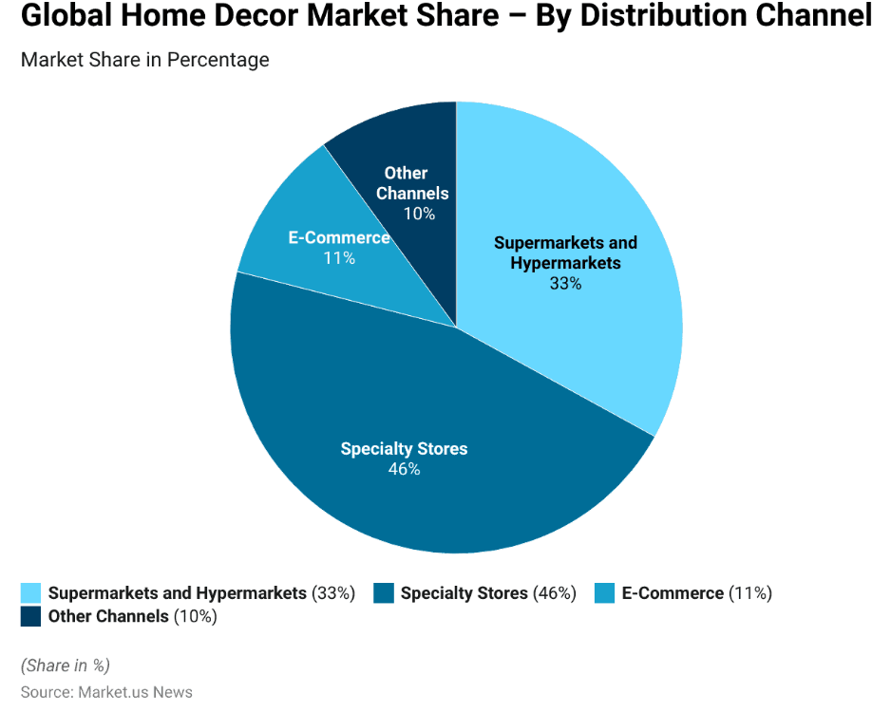

Source: Market.us News

Concurrently, technology-driven platforms like e-commerce marketplaces, augmented reality (AR) applications, artificial intelligence (AI) have revolutionized business performance in the home decor sector. Companies that adopt AR allow customers to view how the furniture would look in their home prior to purchase, removing doubt and re-inforcing customer trust (Devji, 2023). AI personalization optimizes the shopping experience by leveraging product suggestions from browsing and interests, significantly increasing conversion (Mileva, 2025). Although these technologies have a lot of value, companies also have challenges of market saturation, privacy, and evolving customer expectations. This study attempts to examine how digital strategies and technology-driven platforms influence consumer decision-making and business growth in the home decor sector.

**3.Objectives and Research Questions**

This research aims to get a full understanding of how technology platforms and digital marketing strategies impact business performance and consumer behavior. The research aims to answer the following key questions:

* How do digital marketing strategies affect consumer decision-making in home décor?
* How do technology-driven platforms contribute to business growth?

By answering these questions, this study will give an indication of the success of various digital strategies and technology innovations in the home décor industry.

**Importance of the Research**

This study is relevant to companies and consumers within the home decor market. Companies need to understand the role of digital marketing and technology-driven platforms to remain competitive. Companies using data-driven advertising, influencer marketing, and AR/VR shopping can stimulate customer engagement, brand loyalty, and revenue growth (Mileva, 2025). Business insights derived from this study can help companies optimize digital approaches, improve customer experience, and adapt to emerging market trends. As seen from the graph below, showing market revenue by country, the United States is in the lead with $35,440 million, followed by China, Germany, indicating global demand for home decor products.

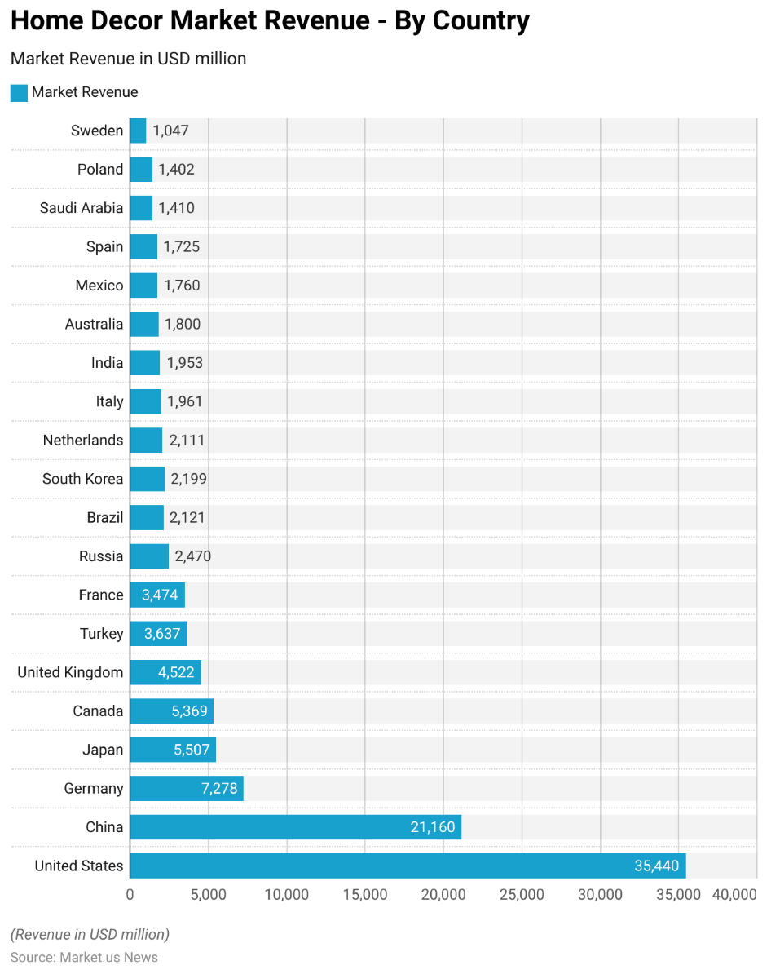

Source: Market.us News

To consumers, technology means numerous benefits, including enhanced convenience, customized recommendations, and interactive shopping experiences. AR capabilities allow consumers to view products at home, whereas AI-driven recommendations allow consumers to find products based on their individual taste and style (Devji, 2023). Additionally, consumer reviews and posts represent social proof that allow consumers to make informed decisions on purchases (Mileva, 2025). As soon as consumers are aware of the influence of digital technologies on their choices, consumers can make wise decisions when purchasing home decor products.

In general, this study will be adding to the knowledge on technology-based business models and online marketing for the home decor industry, and offering valuable insights to industry stakeholders.

**4.Literature Review**

The home decor industry is a form of self-expression, aesthetic, and creative enterprise and the past few years have witnessed a change in how it is showcased to the customers: the emergence of digital marketing and technology-based platforms. They are not bells and whistles; they're at the center of the way customers buy and businesses appeal to their customers. The home decor sector has been revolutionized with the arrival of technology-based platforms, online marketing operations. These technologies have revolutionized the customer behavior and fast business expansion. This literature review brings together evidence of reliable studies, with due regard for the multi-sided effects of these developments on the home decor sector.

**Growing Internet Sites and their Impact**

Cheng, Sokol, and Zang (2024) provide a broad outline of the trajectory of online research on the new millennium. The research classifies online platforms into search platforms, online shopping platforms, online communities, mobile platforms, and gives framework to view their economic worth. The authors note that online stores like Wayfair and Amazon are the hub of the home furnishings market, performing as go-betweens that act as a conduit between consumers and a variety of products. Access to them has given consumers, while enabling small businesses to compete on a global platform. The research also informs us of the importance of platform ecosystems, where third-party sellers introduce diversified forms of products, contributing to customer satisfaction and business development.

**Consumer Engagement and Internet-Based Marketing Tactics**

Li (2024) analyzes the effect of online advertising on consumers' behavior with emphasis on the social media sites. The study determines that online advertising synonymous with social media marketing and has significant effects on customers' buying habits. On the home decor front, social media websites like Instagram and Pinterest are web-based showrooms, where the consumer gets inspiration and is educated about the product. Li's research shows that influencer collaborations and user-generated content support brand credibility and interaction. For example, by customers sharing photos of their home interior environment, not only is the product sold but the community is built around the brand, leading to increased trust and sales.

**Application of Artificial Intelligence in Advertising**

The paper by Coffee (2025) describes the changing role of artificial intelligence (AI) in online advertising, highlighting the way AI technology is making basic operations such as advertisement placement, audience targeting, design easier. In home decor, AI-based ads give business the ability to convey personalized messages to customers, thus making marketing more relevant. For example, AI can possibly scan consumer browsing histories to show them home decor products that are relevant to them, encouraging them to buy, however, the article also highlights an issue with a lack of control and transparency for marketers, as AI systems use advanced algorithms that are not necessarily transparent. Therefore, it is necessary to take a balanced approach that can benefit from the efficiency of AI and remain vigilant about the ethical ramifications.

**AI, AR, and Data-Driven Marketing Role in Home Décor Industry**

The research of Liu and Chen (2024) revolves around the evolution of home decor business against the background of prevailing digital advancements, i.e., those related to artificial intelligence (AI), augmented reality (AR), data-driven marketing. The paper highlights how these digital advancements have transformed the interaction between customers and brands as well as the shopping process through personalized recommendations, enabling interactive shopping experiences, and increasing customers' engagement.

One of the most significant discoveries of the research is that AI-based recommendation engines enhance the customer experience by learning consumer behavior and offering personalized product recommendations. Personalization maximizes engagement and conversion rates as customers are likely to buy products that fit their style and history. Likewise, the research illustrates how AR apps, including virtual room planners and 3D visualization software, enable consumers to test furniture and décor in rooms prior to their purchase and this experiential element eliminates uncertainty and returns, and the online shopping experience is more reliable and engaging.

Besides, Liu and Chen (2024) explain the use of data-driven marketing strategies, such as predictive analytics and behavioral targeting, to enhance business growth. Home furnishing companies utilize big data to optimize advertisement, pricing strategy, and customer retention. Nevertheless, the research also identifies some of the challenges, such as data privacy issues, high implementation cost, and customer adjustment to new technologies.

The research offers key insights into how technology-enabled platforms are influencing customer patterns and business expansion in home decor, affirming the necessity for brands to adopt digital innovation to stay ahead.

In conclusion, technology and digital marketing are transforming the entire landscape—everything from how consumers find and purchase products to how companies grow and compete. Social media and influencers are fueling engagement, AR and VR are revolutionizing the shopping experience, and AI is personalizing and automating everything. For companies, the potential is enormous, but so are the risks. The winners will be those who leverage these tools while remaining committed to what matters most: providing value to their customers. As the industry continues to evolve, one thing is certain: home design's future is digital. And for those businesses that actually comprehend, the future is boundless.

**5.Research Methodology**

This study employs a secondary research approach to studying the influence of technology-enabled platforms and online marketing on consumer behavior and business growth in the home decorating industry. Based on available academic research, firm reports, and data statistics, the study is likely to provide detailed insights into digital change in this industry.

The study relies predominantly on secondary data collection, aggregating data from peer-reviewed journals, market studies, and internet statistical databases. Research papers from established publishers such as Wiley, SAGE, and Taylor & Francis offer theoretical data on digital marketing, consumer behavior, and the role of technology on business performance. Market studies and trends from Market.us News, Statista, and McKinsey & Company etc also offer empirical data on shifting consumer trends and the effectiveness of digital methods.

The conversation is grounded in leading digital marketing mediums such as social media, influencer marketing, search engine optimization (SEO), email marketing, and artificial intelligence (AI). Furthermore, consumer behavior data such as the power of visual inspiration, online reviews are examined to identify decision-making patterns.

By synthesizing existing research and industry statistics, the approach ensures a balance in examining the impacts of digital marketing on the home fashion market. The findings can allow businesses to better align their marketing activities online to effectively meet shifting consumer trends and requirements in local markets.

**6.Findings and Discussion**

**6.1Consumer Interaction with Online Marketing**

Online marketing is one of the main pillars in the home furnishings industry for connecting with consumers and building brand loyalty. Consumer engagement with brands online has been transformed dramatically, and some content and sites perform better than others.

**6.1.1. Which platforms do consumers engage with most?**

When it comes to online marketing for home decor, not all websites are equal. Some have become clear winners with consumers, due to their visual format and potential to spark creativity. There are various benefits reaped by companies which use social media for as part of their digital marketing strategies. The following graph depicts the same.

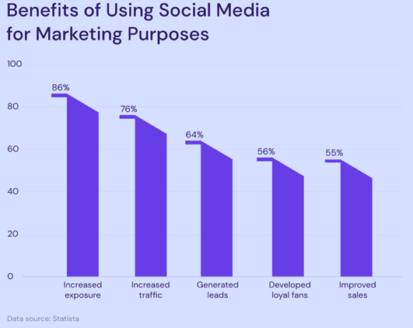

Source: Statista

“86% of marketing professionals saw social media as a key tool in improving brand exposure, while 76% believed it has helped them increase site traffic. Marketers also employ social media to generate leads (64%), build a loyal fan base (56%), and boost sales (55%)” (Hostinger, 2024).

**Instagram: The Visual Powerhouse**

Instagram is likely the most influential platform for home decor brands. Its visual focus makes it a natural fit for an industry that rises and falls on looks. Instagram's visually-driven design allows brands to show products in context, allowing consumers to more easily envision how products would look in their own homes.

For instance, a photo of a stunningly decorated living room can encourage followers to replicate the aesthetic, stimulating engagement in the shape of likes, comments, and shares. Instagram Stories and Reels have further increased the impact, opening new channels for brands through which to push behind-the-scenes content, tutorials, and time-based promotions. The algorithm of the platform also prioritizes high-engagement posts, thus creating a feedback loop that encourages engaging and compelling posts.

**Pinterest: The Idea Hub**

Pinterest is another major player in home decor. In contrast to Instagram, which is more of an instant-gratification platform, Pinterest is a long-term source of inspiration. People are more likely to create boards to pin ideas for future projects, so it is an important source for brands who want to remain top-of-mind. Pinterest's emphasis on planning and discovery makes it especially well-suited to high-involvement purchases such as furniture and décor

For instance, a pin featuring an image of a contemporary minimalist bedroom can be pinned by an individual who is remodeling their home. The pin has the potential to induce repeat purchases in the future as the consumer tries to get the same look. This gives Pinterest significant power of conversion and engagement.

**TikTok: The Rising Star**

TikTok has rapidly emerged as a leader in home decor, especially among younger consumers. Its short-form video format is ideal for demonstrating DIY projects, before-and-after makeovers, and fast design advice. TikTok's algorithm prefers genuine, real-world content, so it is the best platform for user-generated content and influencer partnerships.

For example, a trending TikTok video of a budget room makeover can be seen by millions of engaged users. The emphasis of the platform on creativity and uniqueness resonates with consumers and therefore is a valuable platform for brands to reach Gen Z and Millennial consumers.

**Facebook: The Community Builder**

Although Facebook is not as image-oriented as Instagram or Pinterest, it is still a strong presence within the home design world. Facebook Groups, moreover, have become home for home remodelers and DIYers. The groups allow users to share tips, ask questions, and show off their projects, and they offer a sense of community that fosters engagement.

Facebook's large user population and robust advertising capabilities make it a popular platform for delivering high levels of exposure. For example, a business may use Facebook advertising to target homeowners who are interested in home decor and drive traffic to their site or store.

**6.1.2 What Type of Content Gets the Most Interaction?**

All content is not equal. In home decor, some content works better in engaging customers on a daily basis because of their ability to influence, educate, and connect customers at a deeper level.

**Visual Inspiration: The Power of Imagery**

Visuals rule home decor. Good-quality images and videos that display products in actual-use environments are really good at engaging. People are more inclined to engage with content that enables them to imagine how a product will appear in their own environment.

For example, an image of a cozy reading nook with a trendy armchair and floor lamp can make the followers try to replicate the look in their homes. Companies that consistently post aesthetically pleasing content will tend to draw a loyal base of followers and have higher engagement. The following graph depicts the types of video content that marketing teams invest in for best results.

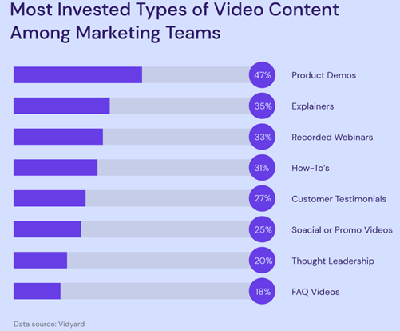

Source: Vidyard

According to Vidyard, the top three most invested types of videos for marketers are product demos, explainers, and recorded webinars.

**User-Generated Content: Authenticity Sells**

User-generated content (UGC) is also amoFng the leading drivers of engagement. When customers share pictures of their homes featuring a brand's product, it's a testimony of something that people have faith in and can believe in, which can't be achieved with conventional advertising. UGC performs particularly well in the home décor category, where individuals are excellent users of word-of-mouth.

For example, a customer's Instagram photo of how they had created a new coffee table in the living room might motivate others to buy. Companies can invite UGC by sponsoring contests, offering rewards, or simply re-posting customers' photos on their own social media sites.

**Collaborations with Influencers: Creating Trust Through Relevance**

Influencer marketing is becoming more and more a component of digital marketing for the home decor industry. Home remodeling and interior design influencers have developed devoted followers with inspirational and relatable content.

For example, an influencer's Instagram picture of a business's new line of throw pillows will receive thousands of likes, comments, and shares. The point to keep here is to tap influencers with similar values and customer base as the business, and whose visual aesthetic will work well with the business.

**Educational Content: Providing Value**

Educational content, such as how-to guides, design tips, and DIY guides, is also a good method of engagement. Home furnishings consumers will most likely look for inspiration and advice and hence educational content is in great demand. Brands providing useful information are likely to establish trust and loyalty with their buyers.

For example, a TikTok guide on how to design a small living room or a blog article on how to choose the appropriate colors of paints can establish a brand as an expert in the niche, creating engagement and conversion.

**Interactive Content: Engaging the Audience**

Interactive content such as polls, quizzes, AR filters is an engagement booster heavy-hitter. Interactive content takes precedence when it comes to active engagement, thus shared and remembered more.

For example, an Instagram poll between two sets of colors for a living room can create a high degree of engagement and provide valuable information about consumer interest. Similarly, an AR filter to enable consumers to "try on" different styles of furniture at home can provide an engaging and interactive experience that increases engagement.

**6.2 Technology's contribution to Customer Experience Enhancement for the Home Furnishing Industry**

Home decor has always been a business of personal and comfortable spaces. But in the modern age of digital technology, with the rise of virtual reality (VR), augmented reality (AR) and artificial intelligence (AI), technology is increasingly becoming a critical part of the customer experience. These technologies are revolutionizing how customers interact with home decor.

**6.2.1. AR/VR Shopping Case Studies for Home Decor**

Augmented Reality (AR), Virtual Reality (VR) are no longer science fiction—now they're real, and they're revolutionizing the home furnishings shopping experience. These technologies allow consumers to view products in their own space, reducing uncertainty and increasing confidence in their purchase.

**IKEA Place: The AR Shopping Innovator**

The most popular AR software used in interior design is IKEA's IKEA Place application. The application was launched in 2017 and allows customers to try IKEA furniture in their homes before they purchase. AR software like IKEA Place has significantly boosted customer satisfaction through the removal of online purchase risk (Ozturkcan, 2020).

As an example, a customer can have the app superimpose a new sofa in his living room, scaling it out in height, color, and position. Not only is this more enjoyable to shop, but it also minimizes returns, to the company's and customer's benefit. IKEA's success with AR paved the way for others to do the same, and AR is now an accepted part of home planning.

**Wayfair's Virtual Room Planner**

Home decor behemoth Wayfair has taken it to the next level with AR in the form of its Virtual Room Planner. This allows customers to virtually plan out complete 3D rooms, trying out different layouts, furniture, and décor pieces. Credence Research discovered Wayfair's AR technology has generated more engagement and conversion by enabling customers to practically see their ideal rooms prior to purchase.

For example, a home worker can try different desk, lighting, and shelving configurations on the Virtual Room Planner. This interactivity not only enriches the shopping experience but also gives the consumer informed decisions.

**Houzz's AR Feature: A Renovation Game-Changer**

Houzz, a home remodeling and design company, has also incorporated AR in the form of View in My Room 3D. It allows customers to see the appearance of furniture and décor products in their actual rooms, down to the minute details of texture and illumination. Houzz's AR has proven effective with high-involvement products like lighting and furniture.

For example, a buyer who needs to buy a new dining table can utilize the feature to envision what various materials and styles would look like in his or her current decor. Such realism establishes trust and confidence, and therefore shoppers will go ahead and buy.

**6.2.2. AI-Driven Buy: Personalization at Scale**

Artificial Intelligence (AI) is also a home decor trendsetter, specifically when it comes to customization. Consistent with the note of consumer behavior, AI can provide individualized advice, design solutions, and shopping experiences that are in accordance with one's needs.

**AI-Powered Recommendations: The Amazon Effect**

Amazon has been a leader in AI-based personalization for many years, and its influence extends beyond browsing and shopping history to home decor too. The site-based recommendation engine relies on machine learning, which goes beyond history of browsing and shopping to provide products that can best fit a customer's interests. Deep personalization is one of the primary drivers of customer happiness and loyalty.

For example, if a buyer continues to browse mid-century modern furniture, the Amazon AI will place similar items towards the top of their suggestions. Not only is this better for buying, but it is also causing consumers to discover items that they might not have found otherwise.

**Artificial Intelligence-Based Design Tools: Tailored to Customer's Preference**

AI is also used to offer customized design experiences. Modsy and Havenly are two firms that use AI to create customized room spaces for a consumer depending on their requirement and budget.

For example, a customer can upload photos of his or her house and get a 3D preview of how the house would appear with some of the furniture and home decor choices. This degree of personalization is not only good for the manner in which one shops, but it provides an additional sense of connection between customer and brand as well.

**Virtual Assistants and Chatbots: Real-time Support**

Chatbots and AI-powered virtual assistants are another way through which brands are optimizing the customer experience. They are always available, providing instant assistance, answering queries, suggesting products, and even helping with design decisions. AI can be used to handle routine questions best and leave the tough ones to be resolved by humans.

For instance, a shopper unclear about the ideal rug size to use in his living room is able to text a virtual personal assistant, ask a few queries, and gain customized advice. This real-time, personalized advice enhances the convenience of shopping while boosting the likelihood of a buy.

**6.2.3 Why Personalization Delivers Greater Customer Satisfaction**

Personalization is not a trend—although it's sometimes used as one—it's one of the top drivers of customer satisfaction for the home furnishings market. By personalizing the shopping experience, brands can build a relationship and a trust that repeat customers.

**Personalized Recommendations: Making Shopping Easier**

One of the most evident methods through which personalization increases satisfaction is product recommendation based on individualized preferences. Customer is more inclined to purchase when the brand shows sensitivity toward the customer's needs and wants.

For example, a shopper who frequently purchases green products will be pleased to see sustainable products included in their recommendations, so it not only saves time, but it also reflects the brand's faith in living up to the values of the customer.

**Personalized Marketing: Building Emotional Bonds**

Personalization is also used in online marketing efforts like social media marketing and internet email marketing. By using data to create content that is meaningful, businesses can use this to create emotional connections with consumers.

For instance, a product message about what a customer has viewed or bought in the past is more relevant and less intrusive than an offer as usual and the personalization makes the customers feel special and, hence, more brand loyal.

**Solutions That Address Personal Needs**

Lastly, personalization allows companies to create their own unique solutions that are tailored to the specific needs of each and every customer. Ranging from bespoke furniture to bespoke room planning, these solutions are one-of-a-kind and provide customers with a sense of accomplishment.

For example, a customer seeking a customized dining table can work with a brand to create a one-of-a-kind item that fits their home and style and this not only enhances the customer experience but also makes the brand stand out.

**6.3 Indicators of Business Growth: Measuring the Effect of Internet Strategies on Home Furnishing Business**

In home furnishings, digital work isn't simply about keeping up—it's about making real, measurable progress. From powering return on investment (ROI) to growing market penetration and establishing brand loyalty, businesses are leveraging digital capabilities to turn visions into reality.

**6.3.1. ROI of Digital Strategies: Measuring Success**

When digital strategies are on the table, ROI is the bottom line. Businesses must have their marketing and technology investments return to them. Here's how digital strategies are creating ROI for home decor.

**The Power of Data-Driven Marketing**

Marketing activities like PPC advertisements, social media marketing, and email marketing are extremely measurable, where it is much easier to track ROI. Through data-driven marketing, businesses can optimize in real-time to create maximum impact.

For example, a home decor brand that is running a Facebook ad can track its click-through rate, conversion rate, and cost per acquisition. With this analysis of data, the brand can optimize its targeting, messaging, and budget to produce better results. This is as targeted as marketing can be to make every dollar spent pay off.

**AR/VR: Lowering Returns, Boosting Sales**

Augmented Reality (AR) and Virtual Reality (VR) technology are also providing stunning ROI by reducing return rates and establishing customer trust. Firms that use AR/VR technologies have seen a drastic reduction in product returns, which can be an enormous cost to online retailers.

For example, a customer who, through an AR app, is able to see how a sofa would look and fit in his or her living room will be less likely to return it if it does not fit or look the way he or she wants. This not only saves the company money but also results in higher customer satisfaction, which is translated into repeat sales and more lifetime value.

**AI-Powered Personalization: Conversion Driver**

Artificial Intelligence (AI) is another ROI driver that enhances customer experience. AI-based one-to-one marketing campaigns, chatbots, and recommendation engines have been shown to drive more conversions.

For example, a product suggestion email campaign by AI based on the browsing history of the customer is more likely to result in a sale than a mass promotion. The targeted aspect of the campaign renders the marketing both efficient and cost-effective.

**6.3.2 Market Expansion: New Market Expansion**

Digital strategies are also making home décor brands reach out further, both geographically and demographically. Subsequent section looks at how technology is assisting firms to reach out to new markets.

**E-Commerce Websites: Breaking Geographical Barriers**

Platforms such as Amazon, Wayfair, and Etsy have brought home decor brands onto the global stage. The home decor market will expand at a compound annual growth rate (CAGR) of 11% from the forecast period 2024-2032, as per Credence Research.

For instance, a tiny home furnishings company that produces products manually can now sell its products to global customers via platforms such as Etsy. This type of access did not exist twenty years ago and is opening up new channels for growth.

**Social Media: Building a World Community**

Social media platforms like Instagram, Pinterest, and TikTok are also driving market growth. Social media platforms give brands an avenue to market their products in front of a global market, build loyal customers, and drive traffic to their websites. Social media has become an active platform for engaging with young, tech-savvy customers who crave authenticity and uniqueness. “Social media and online design platforms like Pinterest, Instagram, and Houzz have significantly influenced the Online Home Decor Market by shaping consumer trends and inspiring home improvement projects” (Credence Research, 2024).

For instance, an organization that shares stunning content on Instagram is able to acquire followers from around the world, some of whom can be converted into customers. Social media also allows brands to interact with their followers in real time, developing relationships that equate to sales.

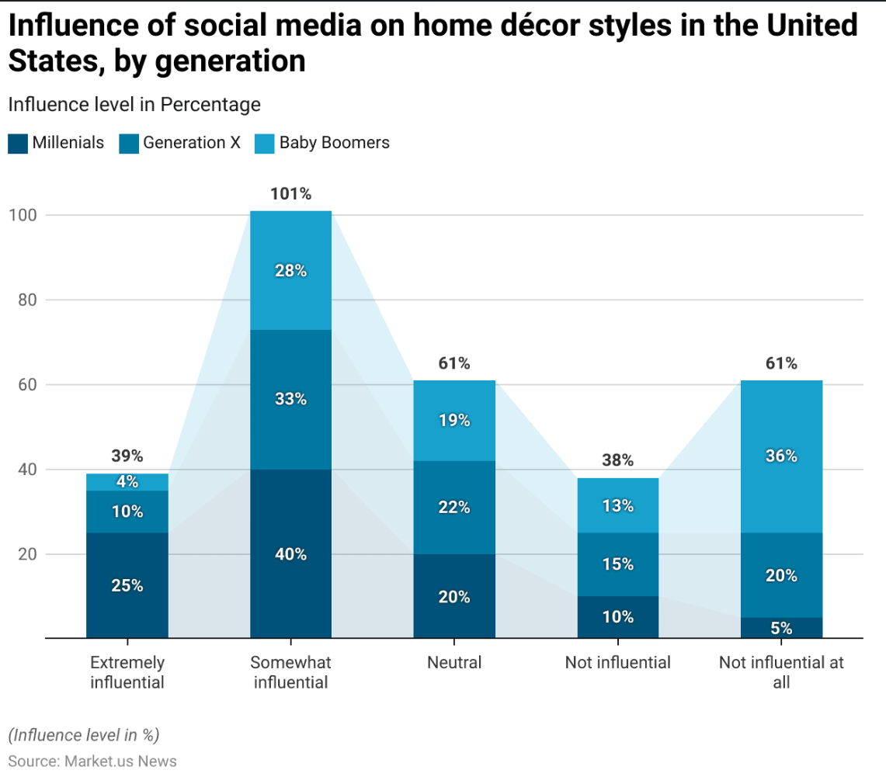

Source: Market.us News

The graph highlights the varying influence of social media on home décor preferences across different generations in the United States. It can be seen in the graph 25% Millennials find social media extremely influential for home décor styles in the U.S., followed by 10% of Generation X, and 4% of Baby Boomers. This data emphasizes the critical role of social media platforms in shaping consumer behaviour, particularly among younger demographics. Businesses in the home décor industry should focus on targeted digital marketing campaigns that cater to the preferences and engagement habits of each generation, leveraging platforms like Instagram and Pinterest to maximize reach and impact. By understanding these generational differences, companies can better align their strategies to meet the evolving demands of their diverse customer base.

**Localized Marketing: Tailoring Strategies to New Markets**

When companies venture into emerging markets, there is localization marketing. This involves content translation, cultural fit, and local offerings. “In Japan, minimalistic and traditional designs dominate the home décor market, reflecting the country's cultural emphasis on simplicity and harmony” (Statista, 2024).

For example, a home furnishings company expanding into the Asian market can launch regionally specific products appealing to local tastes and design sensibilities, such as minimalist or feng shui products. Through localized products and communications, brands can reach new consumers and drive growth.

**The following graph shows the top rated home décor styles in the United States:**

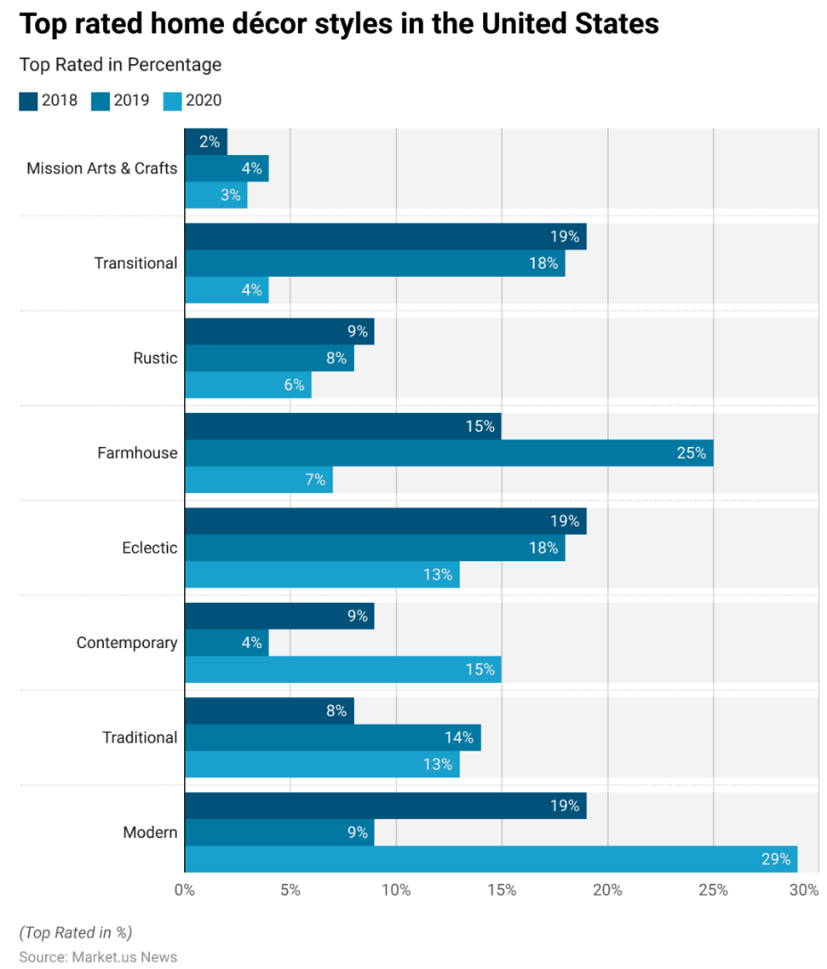

Source: Market.us News

The chart gives a glimpse of various top rated home decor trends in the United States from 2018 to 2020, such as the steady rise of Modern styles and Contemporary styles. The information shows the application of online marketing strategies based on regional consumer preferences to propel business. With technology-driven platforms, businesses can monitor regional demand streams and adapt marketing approaches to regional tastes and thus attain greater engagement and improved sales.

**6.4 Trends and Challenges in the Home Decor Industry**

Although technological advancements and online platforms have brought unprecedented opportunities to the home furnishings industry, they also carry in-built complexities. Businesses have to navigate a multi-dimensional environment, such as privacy issues, over competition, changing consumer behavior in a bid to maintain their competitive advantage. While new innovations are revolutionizing the business space, opening up new possibilities for innovation and growth, as well.

**6.4.1 Privacy Issues: Between Personalization and Security**

As home furnishings businesses increasingly use data to customize the customer experience, privacy has emerged as a top priority. Consumers are more particular than ever about what they do and do not want to do with their data and are expecting the brands to care as much as they do.

**Consumer Trust and Data Collection**

In order to provide customized experiences, brands harvest large volumes of information, from browsing history to buying habits, even location. Though this information is critical in order to customize recommendations and promotional messages, it is also raising questions regarding security and privacy. Consumers prefer to trust those brands that explain what they are doing with data and provide straightforward opt-out possibilities.

The following infographic highlights how final consumers as well as B2B purchasers stop buying from a company because of violation of digital trust, leading to dead weight loss for the company as well as the economy due to decreased company sales as a result of decreased demand.

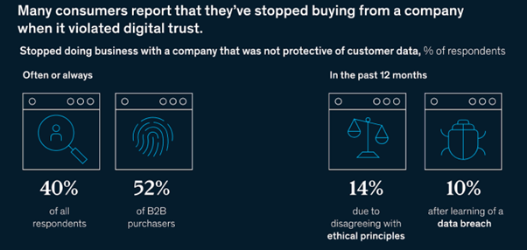

Source: McKinsey and Company, 2022

For example, a home furnishings business that monitors user behavior via cookies needs to detail how the information will be used and provide users with an easy opt-out option. Otherwise, there is a risk of loss of trust and damage to the company's reputation.

**Regulatory Compliance: Navigating GDPR and Beyond**

Data privacy legislation like the EU's General Data Protection Regulation (GDPR) and the US's California Consumer Privacy Act (CCPA) has added an added level of complexity. Brands must ensure their data handling is in accordance with these legislations, which can be difficult, especially for small companies.

For example, a home furnishings company with operations in several regions needs to make sure that its website and advertising are compliant with the privacy law of each region. This means constant monitoring and adjustment, which can be costly.

**Establishing a Culture of Privacy**

To address these issues, brands must adopt a privacy-first culture, where openness and data security take precedence. This entails investing in safe technology, data privacy best-practice employee training, and regular data practice audits. Privacy-focused brands are likely to gain long-term customer trust. Following graph highlights the important factors considered by consumers for a buying decision:

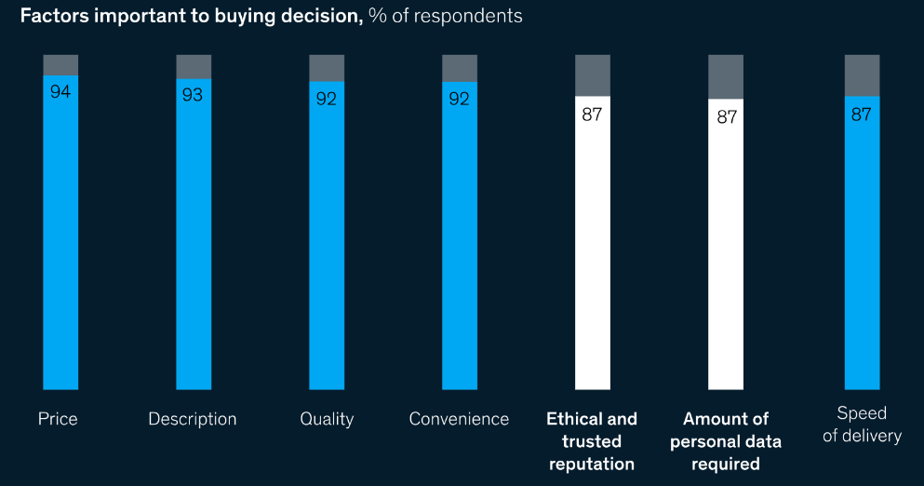

Source: McKinsey and Company, 2022

The graph highlights the importance of trustworthiness and data protection for consumers. “Consumers even believe some digital-trust tenets are nearly as important as common purchase decision factors, such as cost and delivery time” ([Boehm](https://www.mckinsey.com/our-people/jim-boehm) et al, 2023).

For example, an organization can use end-to-end encryption on customer data and provide regular reports on data security. This proactive step not only minimizes risks but also enhances the image of the organization.

**6.4.2. Competition: Standing Out in a Saturated Market**

The home furnishings market is highly competitive with long-established incumbents and new players vying for eyeballs of consumers. Internet strategies lowered

the entry barriers, enabling smaller brands to compete more readily but, at the same time, intensifying competition.

**The Rise of Direct-to-Consumer (DTC) Brands**

Direct-to-consumer (DTC) companies are disrupting the home furnishings industry by offering high-end products for very affordable prices, at times with strong focus on green sustainability and socially conscious production methods. DTC companies are particularly attractive to Generation Z consumers for whom transparency and authenticity are key values.

For example, a green furniture DTC brand can use social media to highlight its green credentials and appeal to green consumers. Traditional brands will find it difficult to imitate this authenticity.

**Differentiation through Innovation**

In order to differentiate themselves in an over-saturated market, brands need to focus on innovation. This could involve providing exclusive products, utilizing the latest technology, or providing memorable customer experiences.

For example, a company can utilize augmented reality (AR) to provide virtual room design consultations, where customers can see how products would look in their homes prior to purchase. Such a new-age approach not only improves the customer experience but also differentiates the company from competitors.

**Competing on Customer Experience**

Customer experience is the determining factor in a competitive marketplace. Brands that are convenient, personalized, and support-driven are more likely to acquire customers. Businesses that invest in smooth online experiences and fast customer service experience increased retention and customer satisfaction. “To stay competitive, I believe marketers need to embrace emerging technologies, prioritize personalization and adapt to shifts in consumer behaviour. AI, voice search, AR and video will dominate digital marketing in 2025, while data privacy and sustainability will become essential for shaping customer relationships” (Bansal, 2024).

For example, a business with free shipping, easy return, and customer support accessible through 24/7 is much more likely to obtain a loyal customer base compared to those without it. These minor but important pieces of information count for a significant amount in an extremely competitive industry.

**6.4.3. Emerging Trends: What's in the Future for Home Decor?**

There are several trends in the future that will shape the future of home decor.

**Shifting Consumer Expectations: Keeping Up with the Times**

Customer needs continue to evolve with technological innovations, shifts in culture, and transformation in lifestyles. The brands need to be sensitive to such evolution so that they remain relevant.

For example, the following graph shows the biggest future trends in interior design projects in the U.S., companies need to be aware and updated about such upcoming trends to continue meeting customer expectations and stay ahead of their competitors.

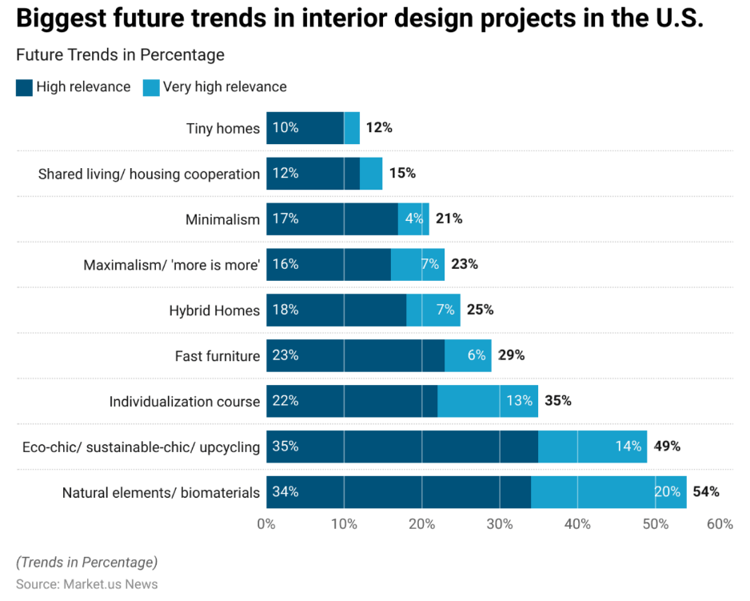

Source: Market.us News

**The Convergence of AI and IoT**

Artificial Intelligence (AI) and Internet of Things (IoT) will add more to the sector. Starting from intelligent household appliances to design software based on AI, the technologies will improve the customer experience further. Firms embracing AI and IoT will be better placed to serve tech-enabled consumers. In the near term, we can expect to have several areas of emphasis: AI will improve the shopper's experience as an individual through the use of data to drive personalization and customer service. It will provide services that are similar to what a consumer receives when they are interacting with a real-world salesperson. As an example, generative AI will help customers locate products, answer questions, complete orders, process refunds (Stabler, 2024).

**Emphasis on Handmade, Local Products and Sustainability**

Given that customers seek originality aa well as uniqueness, local and handmade goods are becoming more popular. Brands that highlight their handcraft and cultural root are likely to resonate with this trend.

Sustainability is no longer a niche issue—now it's mainstream demand. Consumers are becoming increasingly particular about cleaner products and processes, from sustainable raw material right through to ethical production.

An article by Vogue Business (2025) examines the fashion world's conservative adoption of generative AI, considering its environmental consequences. For home decor businesses, this presents an issue: the adoption of AI can yield more immersive customer experiences and streamlined processes but demands a commitment to sustainable practices. Brands are encouraged to responsibly adopt AI so that the technological drive is not at the expense of the environment.

Mass-produced goods drain resources and contaminate the environment, while handmade goods are made with care, usually from eco-friendly materials like recycled wood and natural clay. Such a seemingly minor but significant choice saves waste, conserves resources, and helps preserve the world for generations to come (Maheshwari, 2025). For example, Aari employs the "One Product, One Tree" marketing campaign to promote sustainability and gain environmentally aware consumers. Personalizing digital marketing campaigns in this way can help brands grow their customer base.

For example, a firm dealing in home furniture can use recycled products in its product line or collaborate with organizations with the aim of lowering its carbon footprint. Both these features not only make customers interested in its green motive but also appeal to society in general.

**7.Conclusion**

The home decor industry is undergoing a change, with the growing movement towards technology-powered platforms, internet-based marketing campaigns. The research presents the manner in which changes in technology are influencing customer conduct and business growth, with social media, online shopping, augmented reality (AR), artificial intelligence (AI) being the core drivers in the industry. With customer conduct transforming further, it is imperative that companies change as well with the necessary adaptations, using digital technologies to drive customer experience and tackle the needs of a technology-savy customer base.

Social media sites such as Instagram, Pinterest, TikTok are now strong sources of inspiration as well as interaction platforms, through which the brand communicates with the consumer one-on-one. User-generated content and influencer collaborations have also driven brand awareness and authenticity and thus become a crucial part of promotion strategies now that the growth of e-commerce has also revolutionized home decor home purchases, with online convenience and long lists of products available. Use of AR and AI technologies in combination has also made online buying convenient, allowing consumers to visualize the product in their immediate environment and receive recommendations, eliminating uncertainty, and enhancing satisfaction.

But the industry also confronts some of its biggest challenges simultaneously, including data privacy issues, market saturation, and sustainability pressure. As consumers become increasingly concerned about how their information are handled, companies must prioritize transparency and security in order to build and maintain trust. And greater emphasis on sustainability is a challenge and an opportunity for brands because brands can use it as a vehicle to differentiate themselves with green products and sustainable behavior. In the next few years, the convergence of artificial intelligence (AI) and the Internet of Things (IoT) will continue to shake up the home decor industry by providing more personalized and interactive experiences to consumers and organizations embracing these new technologies and taking early measures to counter concerns around privacy and sustainability will be well-positioned to thrive in a more competitive marketplace.

The future of home furnishings is balance between new technology and what customers need and sustainable strategy. Using technology to track and react to shifting customer behavior, companies can spur engagement and growth, and prosper in the long term in an ever-evolving world. This study confirms the need for ongoing change and innovation, and offers useful guidance for business managers who need to seize the opportunity and sidestep the risks of the digital age.

**8.References**

1. Coffee, P. (2025). *AI Will Soon Dominate Ad Buying, Whether Marketers Like It or Not*. [online] WSJ. Available at: <https://www.wsj.com/articles/ai-will-soon-dominate-ad-buying-whether-marketers-like-it-or-not-3d62b754>?
2. Credence Research (2024). *Online Home Decor Market - Demand, Size and Competitive Analysis*. [online] Credence Research. Available at: <https://www.credenceresearch.com/report/online-home-decor-market>.
3. Doyle, M. (2025). *Why fashion should think carefully about using generative AI*. [online] Vogue Business. Available at: <https://www.voguebusiness.com/story/sustainability/why-fashion-should-think-carefully-about-using-generative-ai>?
4. Farhan Devji (2023). *10 social media marketing tips for home decor businesses - Roomvo*. [online] Roomvo - A simpler, smarter way to shop. Available at: <https://get.roomvo.com/blog-post-10-social-media-marketing-tips-for-home-decor-businesses/>?
5. Fortunebusinessinsights.com. (2024). *Home DÃ©cor Market Size, Share, Trends | Growth Report [2032]*. [online] Available at: <https://www.fortunebusinessinsights.com/home-decor-market-109906>.
6. Hsing Kenneth Cheng, D. Daniel Sokol and Zang, X.-Y. (2023). The rise of empirical online platform research in the new millennium. *Journal of Economics & Management Strategy*. doi:https://doi.org/10.1111/jems.12571.
7. i95Dev Marketing (2024). *A Guide to Navigating eCommerce in the Home Décor and Furniture Industry*. [online] i95dev. Available at: <https://www.i95dev.com/ecommerce-guide-home-decor-furniture-industry/>.
8. Li, J. (2024). Impact of Digital Marketing on Consumer Behavior. *SHS Web of Conferences*, [online] 207, pp.01026–01026. doi: <https://doi.org/10.1051/shsconf/202420701026>.
9. Mauladhika, B.F. (2024). *44 Key Digital Marketing Statistics for Strategic Growth in 2024*. [online] Hostinger Tutorials. Available at: <https://www.hostinger.in/tutorials/digital-marketing-statistics#Marketing_Technology_MarTech_Statistics>.
10. Mileva, G. (2025). *Best Social Media Marketing Strategies For Home Decor Brands*. [online] Influencer Marketing Hub. Available at: <https://influencermarketinghub.com/social-media-marketing-strategies-for-home-decor-brands/>?
11. Nair, K. (2024). *13 Winning Digital Marketing Strategies for Interior Designers - DesignFiles Blog*. [online] DesignFiles Blog. Available at: <https://blog.designfiles.co/digital-marketing-for-interior-designers/>?
12. Ozturkcan, S. (2021). Service innovation: Using Augmented Reality in the IKEA Place App. *Journal of Information Technology Teaching Cases*, [online] 11(1), p.204388692094711. doi: <https://doi.org/10.1177/2043886920947110>.
13. Boehm, J., Grennan, L., Singla, A. and Smaje, K. (2022). *Digital trust: Why It Matters for Businesses | McKinsey*. [online] www.mckinsey.com. Available at: <https://www.mckinsey.com/capabilities/quantumblack/our-insights/why-digital-trust-truly-matters>.